Functional UAT Test Cases

Project Title: Library Management System (LMS)
Project Type: Full-stack Web Development Capstone Project
Document Version: 1.0

Test# | Test Case | Expected Result | Test Result
UAT-001 | Suspended member logs in | Access Denied modal window appears | Passed  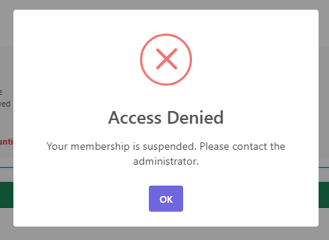
UAT-002 | Member with past dues log in | Overdue Books modal window appears | Passed  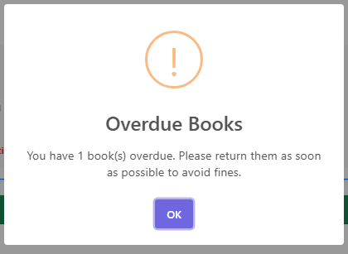
UAT-003 | Member with expired membership logs in and clicks cancel | - Membership Expired modal window appears with buttons Renew Now and Cancel  - When user clicks Cancel, Login failed model window appear with text “Membership has expired. Please renew to login” | Passed  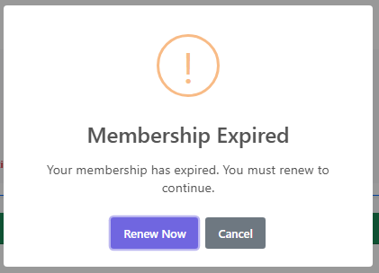  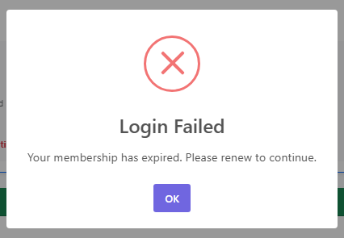
UAT-004 | User borrows 1 book with checkout  - User add book to book cart  - book cart shows badge of 1  - clicking on book cart reveals the book to borrow  - clicking checkout shows success | - When user add book to book cart, book cart badge is updated with 1  - When user click book cart, the book to borrow is revealed  - When user clicks checkout, modal window show success | Passed  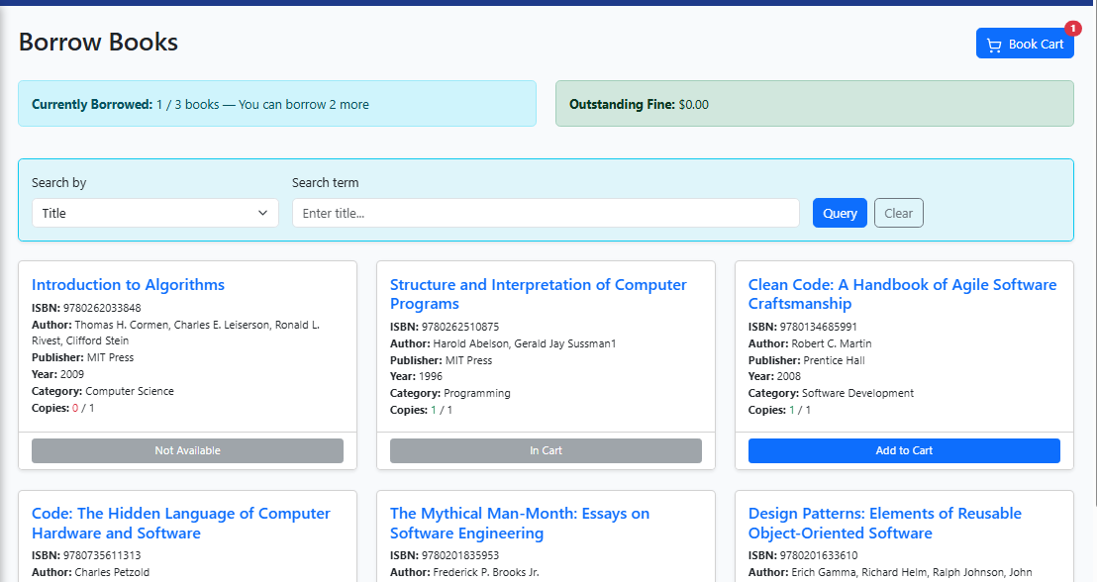  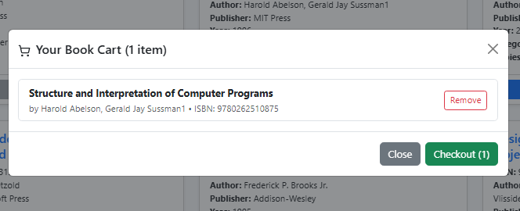  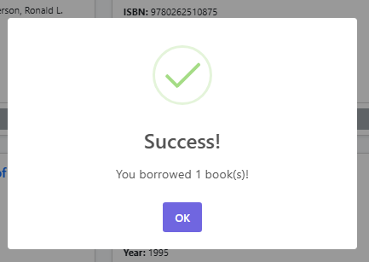
UAT-005 | User try to borrow more than 3 books  - User has 3 books already borrowed  - User tries to borrow more books but unable to. | - Status says “Currently Borrowed: 3 / 3 books (limit reached)  - All buttons on books disabled “Max Borrows Reached” | Passed  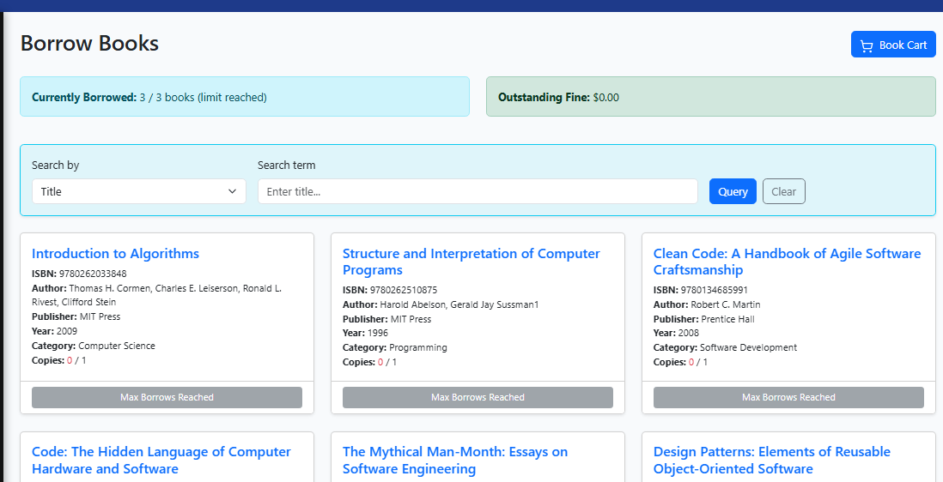
UAT-005 | User has book with past due date and amount < $10  - User access Manage Status page  - User sees a fine < $10 imposed on an overdue book | - Status on the overdue book shows the due date and calculated fines  - Renew and Return buttons are disable with only Pay Fines button enabled | Passed  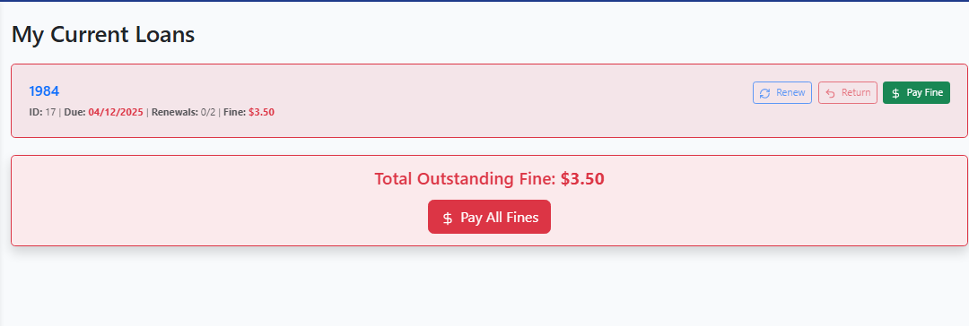
 | User has book with past due date at 45 days  - User access Manage Status page  - User sees a fine of maximum $20 imposed on an overdue book | - Status on the overdue book shows the due date and a maximum fine of $20  - Renew and Return buttons are disable with only Pay Fines button enabled | Passed  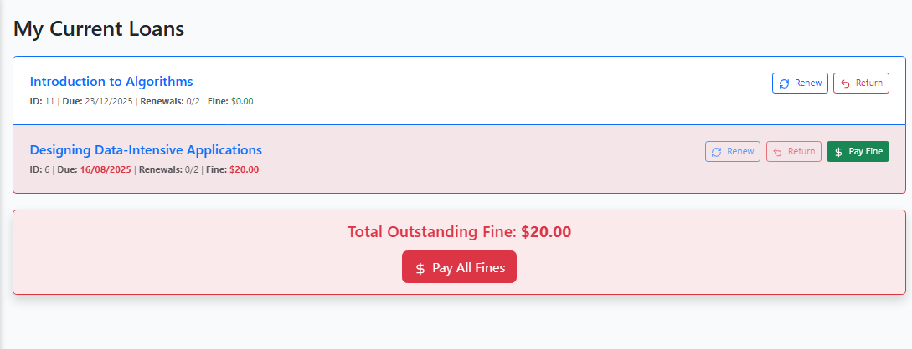
UAT-007 | User pays fines on 1 book  - User clicks on an overdue book to pay fine | - Status shows the status of the overdue and the fine amount  - User clicks Pay Fine  - Modal Window appear to inform user that the fine is paid | Passed  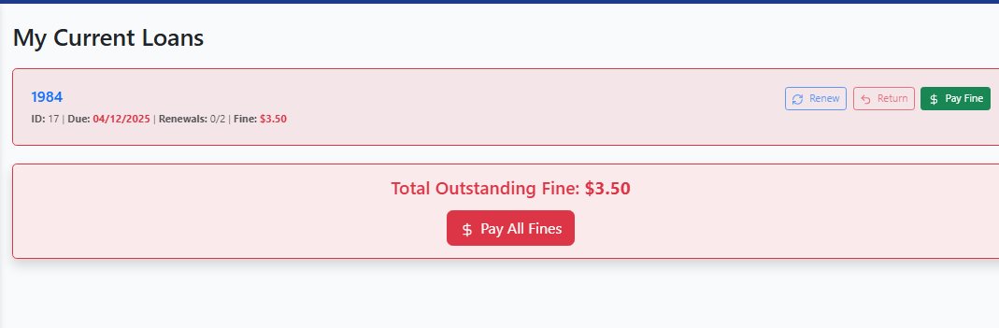  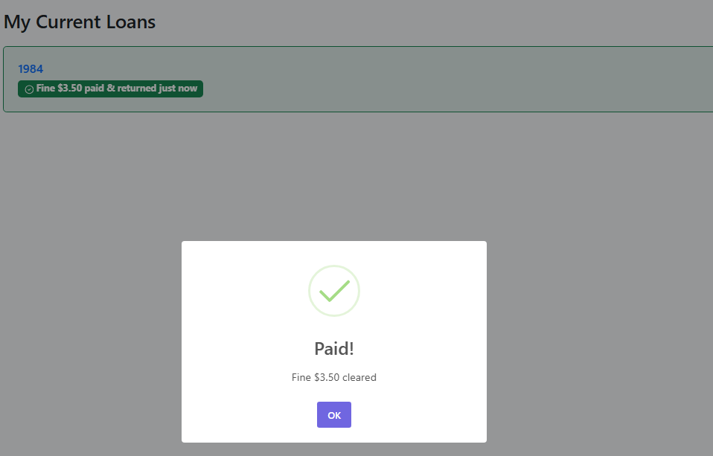
UAT-008 | User makes 1 new reservaton  - User access Make Reservation page  - User clicks on a book and checkout to makes a reservation | - User sees a limted list of books where available copies = 0  - When user selects a book, the Reservation Cart badge is updated  - When user clicks on Reservatio Cart, the book to be reserved is reveal  - When user clicks checkout, a success modal window appears. | Passed  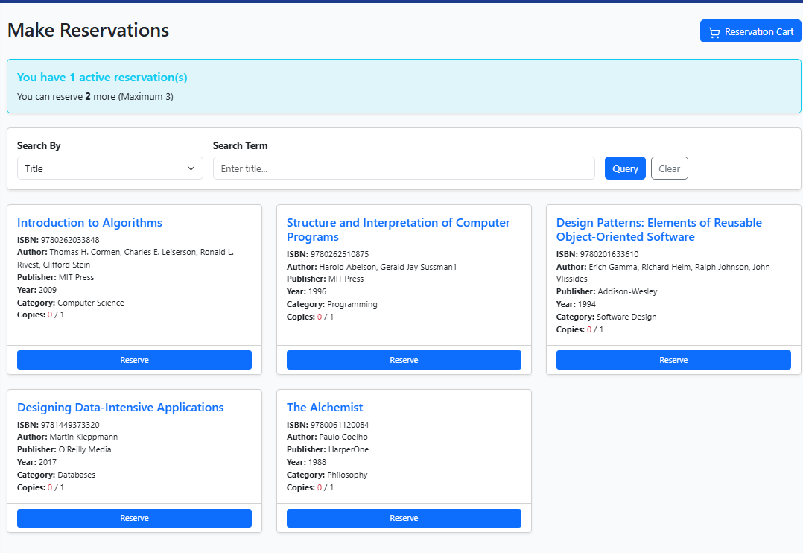  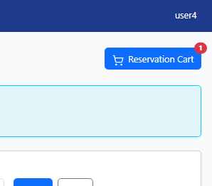  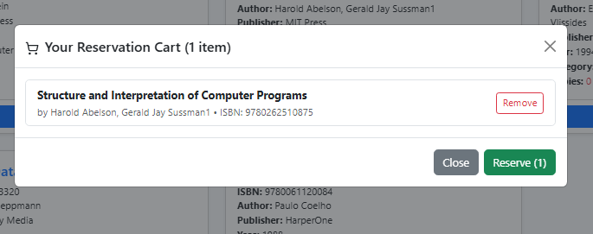  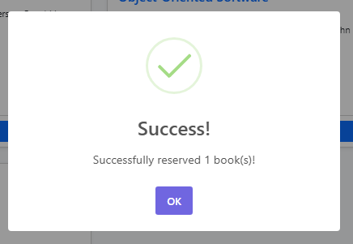
UAT-009 | User cancels 1 active reservation  - User access Manage Reservations page  - User cancels an active reservation | - User see the active reservation for the user  - When user clicks cancel, a Cancel Reservation? Modal window appears  - Clicking on Yes, another modal window appears showing the reservation is cancelled | Passed  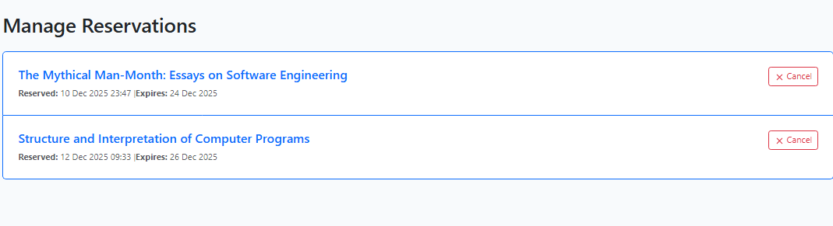  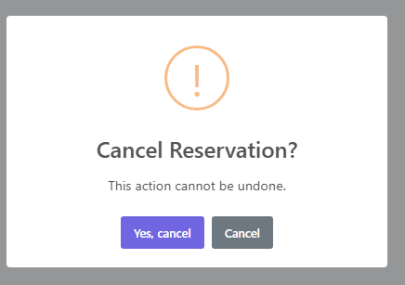  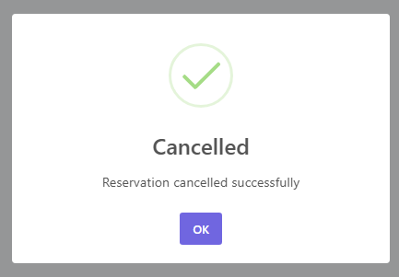
UAT-010 | Admin update member status to suspended  - Admin edits a member entry  - Sets status to suspended | - Admin sees a list of users  - When clicked on Edit on a user, the user edit forms appears  - Admin can change the status to Suspended  - Upon submit, a success notification is recieved  - Back in the users list, the status of the member is now “Suspended” | Passed  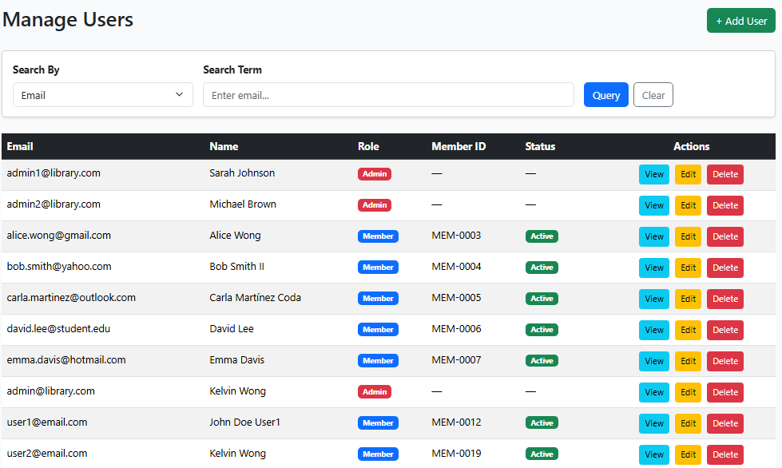  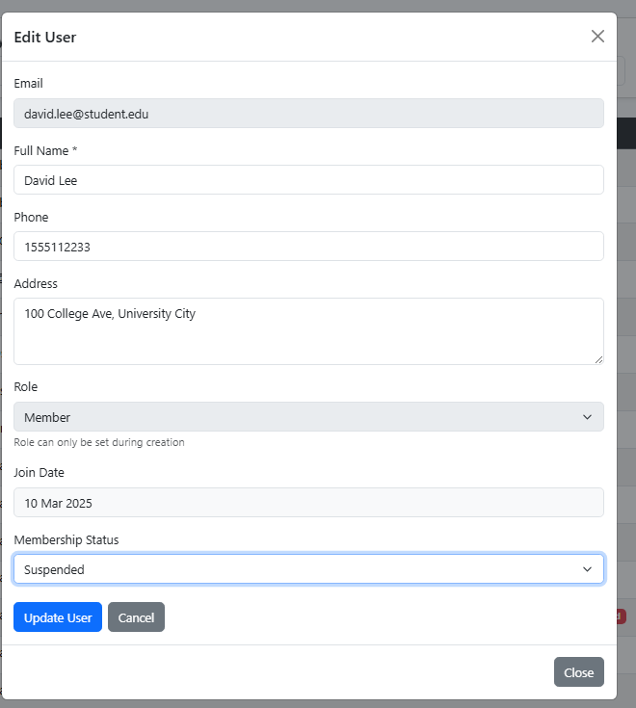  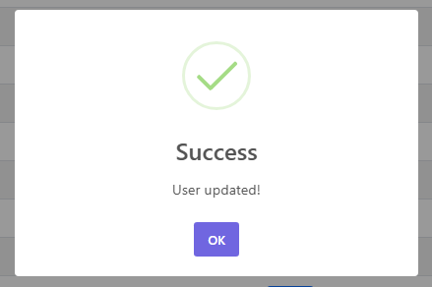  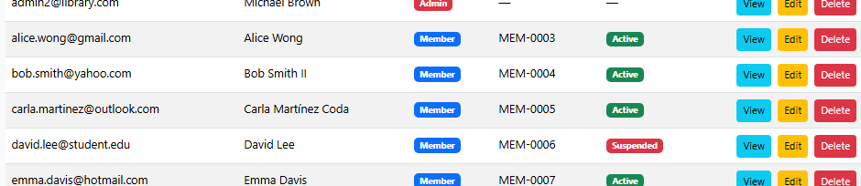
UAT-011 | Admin adds new book  - Admin add new book and submits | - Admin sees a list of books  - When clicked on Add Book and a blank form appears  - Adds details of new book and clicks Add  - Success notification appears  - Back in the users list, when Admin searches for the new book, it appears in the search list | 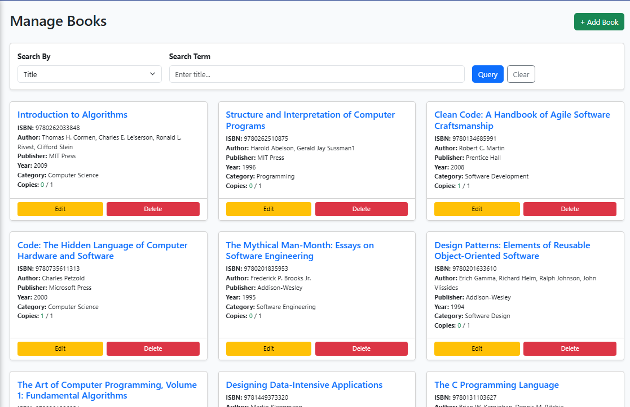  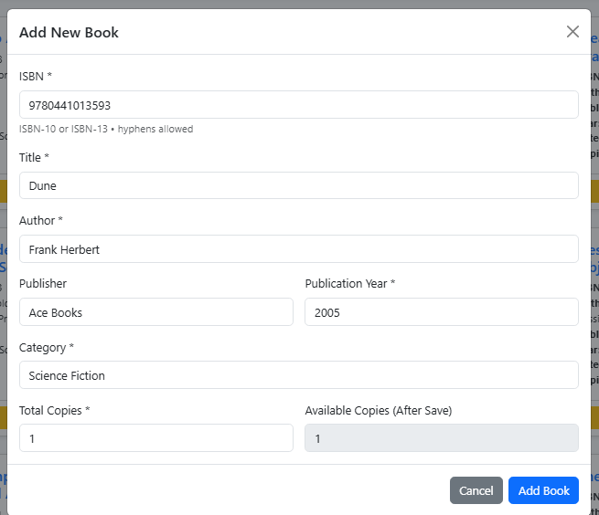  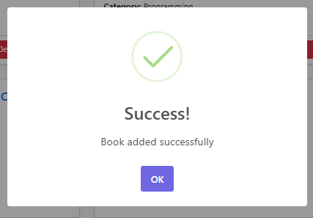  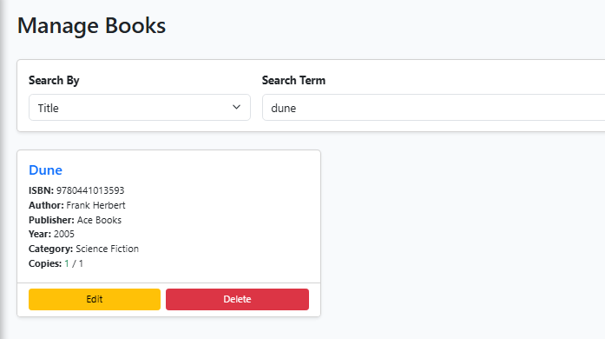
UAT-012 | Admin fulfills a book reservation  - Admin sets a reservation to fulfilled | - Admin sees a list of reservations  - Selects on reservation and clicks fulfilled button  - Modal dialog opens to ask for confirmation, Admin confirms  - Upon submit, status says fulfilled  - Back in the list, the status of reservation is now fulfilled | 